Application: Employee Salary Search Using Binary Search

CO2 AT2
CSA0619 – DESIGN AND ANALYSIS OF ALGORITHMS
Submitted by

M Yasodha Krishna (192472100)
Under the Supervision of

Dr. F. Mary Harin Fernandez
ABSTRACT
Organizations maintain employee salary records to retrieve information quickly. Binary Search is an efficient searching algorithm that works only when the data is arranged in sorted order. In this report, the Binary Search algorithm is explained using sorted employee salary records. The working process, time complexity, and the importance of maintaining sorted data are analyzed to demonstrate the efficiency of Binary Search.
INTRODUCTION
Searching is one of the most common operations in database systems. When employee salary records are stored in sorted order, Binary Search can locate a required salary much faster than Linear Search. The algorithm repeatedly divides the search space into two equal halves until the required element is found or the search interval becomes empty. However, if new records are frequently inserted or updated without maintaining the sorted order, Binary Search cannot be applied efficiently.
PROBLEM STATEMENT
A database stores employee salary records in sorted order. Binary Search is used to retrieve salary information efficiently. Frequent salary updates may disturb the sorted order of the records.
The objectives are to:
- Explain how Binary Search works on sorted data.
- Analyze its time complexity.
- Discuss why maintaining sorted data is important for efficient searching.
OBJECTIVES
- To understand the Binary Search algorithm.
- To search employee salary records efficiently.
- To analyze the algorithm's time complexity.
- To understand the importance of sorted data.
- To compare search efficiency in sorted and unsorted datasets.
SYSTEM DESCRIPTION
The system stores employee salary records in ascending order. Binary Search begins by comparing the target salary with the middle element of the list. If the target is smaller, the search continues in the left half; otherwise, it continues in the right half. This process repeats until the required salary is found or no elements remain.
(a) Working of Binary Search
Consider the sorted salary list:
25000 30000 35000 40000 45000 50000 55000
Suppose we want to search for 45000.
Step 1
Middle element = 40000
45000 > 40000
Search the right half.
Step 2
Remaining list:
45000 50000 55000
Middle element = 50000
45000 < 50000
Search the left half.
Step 3
Remaining element:
45000
Salary found.
Algorithm
- Start.
- Read the sorted salary records.
- Enter the salary to search.
- Find the middle element.
- If the middle element equals the target, display "Salary Found".
- If the target is smaller, search the left half.
- Otherwise, search the right half.
- Repeat until the salary is found or the search space becomes empty.
- Stop.
Python Program:
def binary_search(salaries, target):
low = 0
high = len(salaries) - 1
comparisons = 0
while low <= high:
mid = (low + high) // 2
comparisons += 1
print("\nComparison", comparisons)
print("Middle Position :", mid + 1)
print("Salary at Middle :", salaries[mid])
if salaries[mid] == target:
return mid, comparisons
elif salaries[mid] < target:
print("Searching Right Half...")
low = mid + 1
else:
print("Searching Left Half...")
high = mid - 1
return -1, comparisons
def main():
print("=" * 60)
print("EMPLOYEE SALARY SEARCH USING BINARY SEARCH")
print("=" * 60)
n = int(input("Enter Number of Employee Salary Records : "))
salaries = []
print("\nEnter Salaries in Sorted Order")
for i in range(n):
salary = int(input("Salary {} : ".format(i + 1)))
salaries.append(salary)
print("\nSalary Records")
print(salaries)
target = int(input("\nEnter Salary to Search : "))
position, comparisons = binary_search(salaries, target)
print("\n" + "=" * 60)
if position != -1:
print("Salary Found")
print("Position :", position + 1)
print("Salary :", salaries[position])
else:
print("Salary Not Found")
print("Total Comparisons :", comparisons)
print("Best Case Time Complexity : O(1)")
print("Average Time Complexity : O(log n)")
print("Worst Case Time Complexity : O(log n)")
print("=" * 60)
main()
Sample Input
Employee Salaries:
25000 30000 35000 40000 45000 50000 55000
Search Salary:
45000

SampleOutput
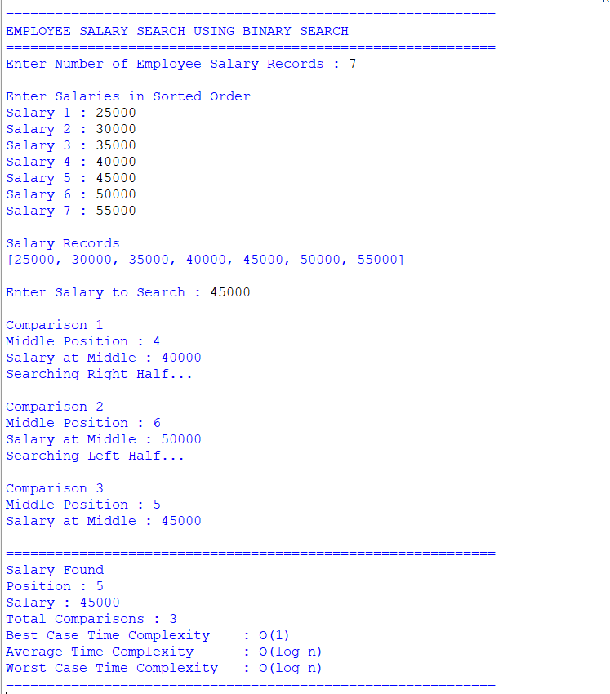

Salary Found at Position 5
(b) Time Complexity Analysis
Case | Time Complexity
Best Case | O(1)
Average Case | O(log n)
Worst Case | O(log n)
Space Complexity | O(1) (Iterative)
Explanation
- Best Case: The target salary is found at the middle position in the first comparison.
- Average Case: The search interval is reduced by half at every step.
- Worst Case: The algorithm continues dividing the list until one element remains.
(c) Importance of Maintaining Sorted Data
Maintaining the salary records in sorted order is essential because Binary Search can only work correctly on sorted data.
If the records become unsorted due to frequent updates:
- Binary Search may return incorrect results.
- The algorithm cannot determine which half of the data should be searched.
- Linear Search may be required instead, increasing the search time to O(n).
- Additional sorting is needed before Binary Search can be used again.
Therefore, maintaining sorted data improves searching efficiency and ensures fast retrieval of employee salary records.
RESULT ANALYSIS
Binary Search significantly reduces the number of comparisons by repeatedly dividing the search space into two equal parts. For large employee databases, this method provides much faster retrieval than Linear Search. However, maintaining sorted data is necessary to preserve the efficiency of the algorithm.
APPLICATIONS
- Employee database systems
- Banking applications
- Student record management
- Library management systems
- Hospital management systems
- Online shopping databases
ADVANTAGES
- Fast searching for large datasets.
- Requires fewer comparisons.
- Efficient for sorted databases.
- Easy to implement.
LIMITATIONS
- Works only on sorted data.
- Frequent updates require re-sorting.
- Not suitable for unsorted datasets.
CONCLUSION
Binary Search is an efficient searching algorithm that works only when data is maintained in sorted order. It reduces the search space by half at every step, resulting in O(log n) average and worst-case time complexity. Maintaining sorted employee salary records ensures fast retrieval and improves the overall performance of the database system.
REFERENCES
- Thomas H. Cormen, Introduction to Algorithms, MIT Press.
- Ellis Horowitz and Sartaj Sahni, Fundamentals of Computer Algorithms.
- Alfred V. Aho, John E. Hopcroft, and Jeffrey D. Ullman, The Design and Analysis of Computer Algorithms.

